Field Day Source Book

By Dean Davis (KL7OR)

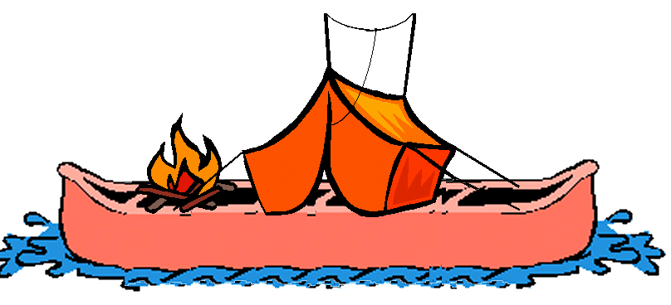

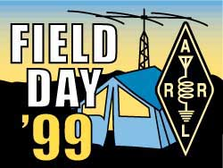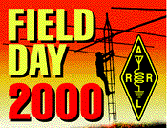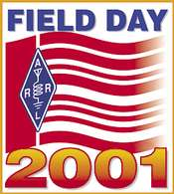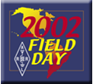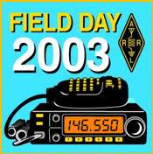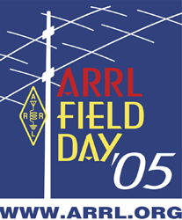

This page blank..

Contents
Introduction 3
Authorship of This Material 3
Field Day is not just a contest 4
Potential Benefits from Field Day 5
Resources 6
Forms and other Documents 7
Willamette Mission State Park 9
4-H Horse Camp, West Salem 10
Calendar 11
Safety 13
Guidelines 13
First Aid 14
First Aid Kit 14
PEOPLE 15
Your Most Important Asset 15
The Incident Command System (ICS) 16
ICS and Field Day Planning 18
An ICS Structure for Field Day Planning & Operations 18
ICS Structure 21
Contest Chief & Shift Supervisors 23
Caution 23
Acquiring Assistants 24
Assignment List 24
Acquiring Operators 25
Receiving Advice 25
Food, Water, Shelter 27
Food 27
Shopping Lists 28
Staple Items 28
Food Items 29
Last Minute 30
Field Day Setup 31
Number of Transmitters 31
Band/Transmitter Control 32
Band Token 32
Rules for control 32
GOTA (Get On The Air) Station 34
Introduction 34
Frequently Asked Questions (FAQ) 35
ANTENNA 37
Finding / Creating 37
Antenna Supplies 37
Installing 38
STATION HARDWARE I SUPPLIES 40
Furnishings 40
Lighting 41
Pieces / Parts / Tools 41
RADIO ACCESSORIES 41
Radio (Rig) 41
Phones, Mikes & Switches 42
Meter, Cables, Components 42
LOGGING HARDWARE I SOFTWARE 44
Recording Instruments 44
SITE PREP & MAINTENANCE 45
Shelter 45
Water 46
N3FJP Computer Logging 47
Overview 47
Primary Features 47
Menu Bar Commands 47
Screens 49
Main Logging Screen 51
STATISTICS REPORTING 52
Scheduling of Operators 52
Reporting to the ARRL 53
Afterglow 54
Appendix A – Antenna Ideas 55
Appendix B – Press Releases 56
Appendix C – Field Day Invitation 57
Appendix D – Information Sheet 58
Appendix E – Forms 59
Appendix F - GOTA Documents/Forms 60
Appendix G – Other Documents 61

Introduction

Authorship of This Material
The material contained in this document has been gathered reformatted and represented here in the hopes of becoming the definitive source book for the annual ARRL Field Day activity in June. While I cannot claim to be the absolute author of the material I would like to give credit to many of the clubs and organizations around the country where I have gathered information. Specifically:

Mike & Key Amateur Radio Club, Seattle WA
West Valley Amateur Radio Club, San Jose CA
Mike Polkinghorn, K6PUD, Santa Rose CA
Nashua Area Radio Club, Nashua NH
Marshall Johnston, KK7CW for his great antenna ideas
Eastern Massachusetts ARES

And if I have forgotten anyone I apologize.

I am kind of a Field Day junkie and 2003 celebrates my 40th anniversary when as a 17 old kid I organized a field day in California. I was a newly licensed novice and the field day bug had hit me very hard. It only seemed natural that when I came back into the hobby in 1989 that I dive back into Field Day, which I have. I do hope that you as a reader with take something form this material and use it. I know of no copy right property rights on any of the material except the Field day logos owned by the ARRL. This document collection is copy righted by my self.

“One giant leap for mankind, one small step for a Field Day Chairman”

The first time we look at a task we are not familiar with it appears to loom up at us like a daunting mountain peak we can faintly see through the mist of drifting clouds surrounding its base. And we are often impressed with the “wonderful talent and aptitude” of those we see scaling this prominence. But those who have taken the adventurous leap of faith to attempt the formidable climb, soon discover that there is a secret more profound than the apparent size of this geologic structure that reveals itself to the first time climber. That truth is this: No one conquers a mountain (task) with his own skill alone.
How does all this translate to being a Field Day Chairman? Well, some of us hang back from the challenge of heading up a committee operation for the Oregon Tualitin Valley Amateur Radio Club when we only see the skillful successes that have gone before us by “long-time” members and “experienced” hams of previous years. Herein too there lays a hidden secret: No ham ever succeeded at Field Day with his/her own skill alone.
What we see as a large, formidable task as “Chairperson” is really the accomplishment of many willing hands working together, not because the chairperson drives them, but because they want Field Day to be a success as much as you do.
So what is left to hold us back from attempting the new and different? Perhaps it is a lack of confidence in handling the unknown. This is where the booklet you are holding right now will open the door to new success and new friends.
In the few and brief pages that follow you will receive step-by-step instructions on the tasks and responsibilities that a committee chairman accepts. Please keep in mind as you read that there is nothing complicated nor technical about chairing a Field Day committee. To prove this point find some time to sit down and read the entire booklet before you accept or reject this opportunity. I recommend that you wait until you have enough time to go all the way through so you can see the whole picture at one time. It will surprise you that anyone can do this job and have fun as well. So accept this challenge and start your novice climb to the summit of Field Day this very day!

Field Day is not just a contest
Field Day is more than a contest or QSL/certificate Operating Event. For most clubs, it is part contest, part camp-out, part publicity stunt, and part emergency-operations exercise.
From the club standpoint, we usually emphasize the field-deployment drill aspects, of course. That's normal and good; a major aspect of Field Day is demonstrating that we can operate in the field. However if your club is an ARES unit, ARES training can also be used in, or combined with, the planning and organization of Field Day, and in the operating style your club chooses.

Potential Benefits from Field Day
- Find out what works in the field and who can bring it
- Communicating with adjacent clubs and Sections under difficult radio conditions
- Practice operating with field conditions and emergency power.
- Organized planning and execution of a sustained effort -- good for Public Service Events planning & coordination and possibly for fitting into Served Agency emergency planning.
- Recruit hams for local club or ARES team
- Invite local College (or high school!) clubs' members that may be staying over the summer to join your Field Day.
- Cross-train hams on each-others' equipment
- Invite ARRL Section / Division officers to visit your FD site.
- Invite (potential) Served Agency & or Government officials to visit your FD site, good for ARES and bonus points.
- Invite the media to promote amateur radio.
- Visit other clubs Field Day in your area.

Resources

Resource | Contact
Water | Crystal Springs  9065 SE Jansen  Clackamas, OR 97015  Tim Holms (503)
Tents/Canopies
Public Relations
VHF/UHF Station | Drew Brasher
CW | Phil Westover
Chappoeg State Park | Dennis Wiley  503.678.1251 x230
Willamette Mission State Park | Ryan Sparks x 25 – or-  Rob Westberg x 23  503.393.1172
4-H Camp, West Salem | Connie Gladish  503.371.7920  conniegladish@proaxis.com
QRP Station | Phil Westover
Safety Cones | Dean Davis
APRS | Fred Sell
SSTV | Fred Sell
Packet | Dean Davis

Forms and other Documents
At the end of this document you will find a number of appendices that contain a number of other documents that are used throughout the life of Field Day including press releases, posters, and the many forms that are needed for the event.

File Name | Description
Attendance Log.xls | This is the sign in sheet for everyone when attended the event including visitors.
Band Chart General.doc | Band Chart for General Class License
Band Chart Tech.doc | Band Chart for Technician class license
FD Dupe Sheet.xls | Generic Dup Sheets. Mostly used for the GOTA station
Field Day Banner.doc | This is the banner we posted around town and at other ham radio events.
Field Day Information.doc | In early sprint it is time to start getting help from your organization. We used this form to collect information.
Field Day Invitation.doc | This is the last form we used and it gives all of the information including checklists.
Field Day Source Book.doc | This document
GOTA Certificate.doc | We issued a certificate for each operator of the GOTA station. This certificate and be taken home and framed.
GOTA CheckList.doc | This is the current GOTA stations band captains check list. Nice format for others to follow.
GOTA FD Log.xls | GOTA station Log Book
GOTA QSO exchange.doc | This is a handy aid used at the GOTA station operator to exchange information with other stations
GOTA Station Log.doc | GOTA station Log Book (another format)
Ham Attenance Log.xls | Sign in sheet just for hams.
Ham Radio License Class Sign Up.doc | Sign up sheet for prospective hams.
Local Contacts.doc | List of local media contacts
Log Sheets.doc | Generic Field day log sheets used in case of computer problems.
Morse Code Poster.jpg | Morse Code chart from the ARRL Archie comic book. Used as a demonstration at the GOTA station.
Press Release1.doc | Our press release format 1
Press Release2.doc | Our press release format 2
SARC Brochure.doc | Our club brochure
Station Sign Up Sheets.doc | Station sign up sheets used by the band captains.
Token Cards.doc | Sample token cards. See text elsewhere in this manual.

Willamette Mission State Park

Call the park ranger at least 6 months in advance and ask to reserve the park area "Mission Lake B" in advance. Ask for the $60.00 per night fees to be waved explaining that the club has been to the park before demonstrating amateur radio emergency preparedness and why we participate in Field Day.

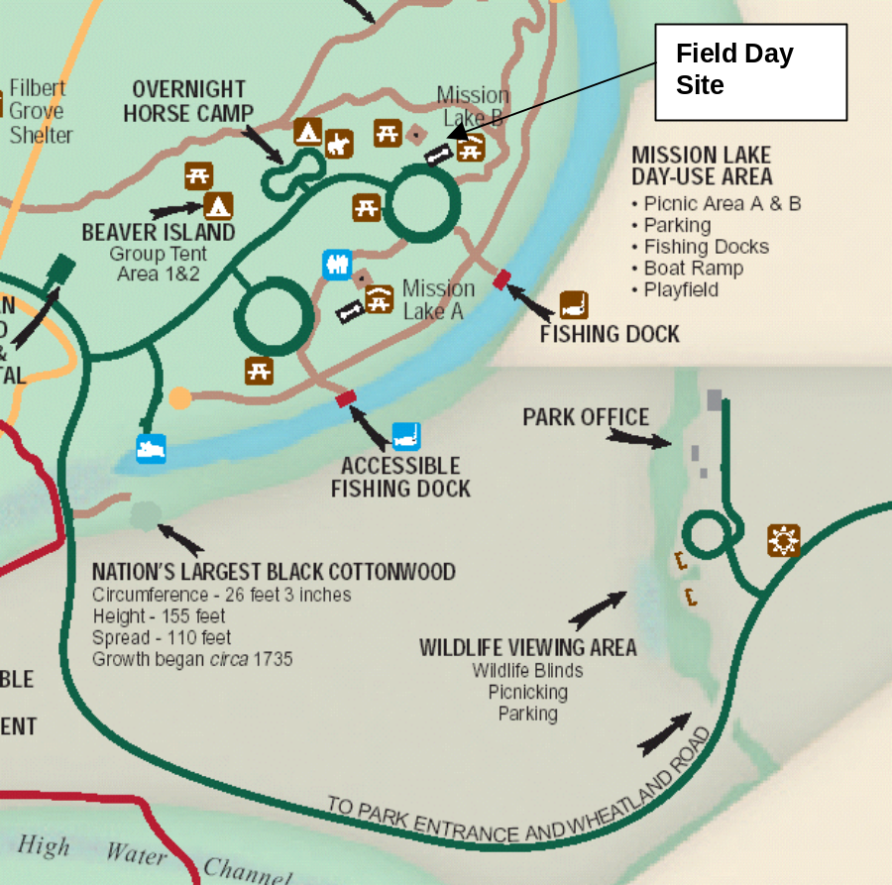

4-H Horse Camp, West Salem

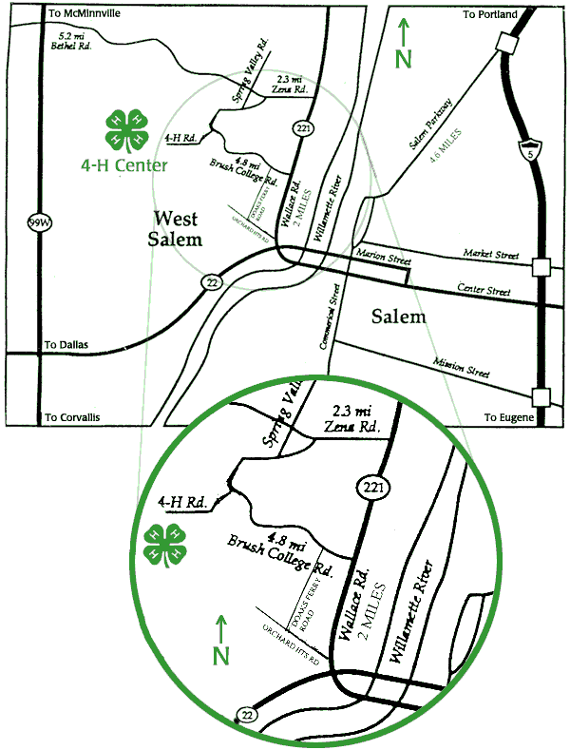

Calendar
The Field Day calendar becomes a vital part of Field Day planning. You will notice that it starts in January 6 months in advance to the event.

January | Field Day planning begins early. There are those that say that Field Day should not be a planned event, but rather should be done as spontaneously as possible. To those I point out that no other emergency service does anything without planning and practice. Firefighters do not show up to a fire and then see if anyone knows how to operate the pumper truck! The same principle applies to ham radio communications. When a real emergency does arise, hams should already know what they have to do to get on the air.  If you ran a station last year, you will hear from the Field Day Coordinator in early January. He will want to know if you will be returning this year. After all, who knows better than you do how to run your station? The Field Day Coordinator wants to know how many Band Captains are returning and how many holes will have to be filled on the roster. Also if you would like a different assignment, this is the time to ask for it. You will find that the Coordinator will do whatever can be done for you. Many times the move can be made. If it can't, try to be understanding and pitch in where you can anyway.
March | In March the planning begins in earnest. You should start recruiting people to help with your station by getting in touch with the people that helped you out last year. The first site walk should be scheduled for the second weekend in March (the first and last weekends are major contests). This site walk is mainly for the Band Captains and anyone who has never been to the site before. The group can survey the site and note any changes that have occurred. Also any changes in the site layout can be discussed at that time. If you have never been to the site or if your station has been moved, you should make sure to go. This is also the time to start collecting your equipment. This will keep you from finding out on June 1st that the part you need is back ordered until late July!  You should continue to work quietly behind the scenes for the next three months. If you get a chance to recruit a new operator, do so.
Early June | When June hits, the frenzy will begin. A Field Day Net should be held on the Club repeaters after the regular Club Net on the first Tuesday. Band Captains should check in and announce if they need any operators or equipment. Likewise members should check in and announce the availability of themselves or their equipment.  A second site walk should be scheduled for the first weekend of June (the second weekend is June VHF QSO Party). This will be the last site walk before Field Day and anyone and everyone who wants to go should be invited. Last minute changes should be discussed with the Band Captains at that time.
June Club Meeting | The June club meeting is usually reserved for Field Day. You should have your station pretty well figured out by this time, but if not you should make any last minute pleas for equipment or operators at the meeting.
Field Day weekend | Finally the event arrives! All of the Band Captains should be on site just as close to the start of the set up time (11 AM local time). If anyone arrives early, they are allowed to place their equipment on the ground at their station location. You should recruit enough help to set up their station, however it is common practice for everyone to band together for tougher jobs such as antenna erection and so forth.  Emphasis should be put on finishing all of the stations before dark on Friday. After the Friday BBQ a testing net should be held. The net should be coordinated on a simplex channel on 2 meters or 70 CM and all of the stations should be listening to the band they will operate on. Each station will be instructed, one at a time, to transmit for a short time. All stations should confirm that they are not receiving any interference from transmitting station. It is important that this net be held on Friday night so that any interference that is detected can be dealt with while there is time on Saturday morning. After the net, all stations should be encouraged to spend some time operating their stations after the net and make sure that everything is working correctly.
Field Day  Friday Night | One other thing to take care of on Friday night is the W1AW bulletin. It will be broadcast on voice, teleprinter, and CW at various times on Friday afternoon and evening. You should try to copy it down, especially if you are on one of the digital stations. The ARRL has been known to inform you of extra bonuses in the bulletin.
Field Day  Saturday Night | On Saturday, you should prepare for the upcoming contest by "reserving" a frequency. Find an open frequency 10-20 minutes before the start of the contest and call CQ and if possible start a QSO to occupy the frequency. Then as the contest starts, you can sign off from the QSO and start calling CQ Field Day.  The contest will smoothly (or not) until the evening BBQ. This is the highlight of the event! This, however, presents quite a quandary for the Band Captain. Obviously you will want to join in the gathering. At the same time, any time off represents lost contest time and potentially lost QSOs. Some Band Captains will decide to keep working their radios. If that is the case, let the Coordinator know so food can be delivered to you. Other operators will simply shut down their stations. A good compromise is to make a shift change at mealtime. Have an operator finish eating and then replace the operator currently on shift. This way both ops get to enjoy the BBQ and the station stays on the air.  The contest will grind through the night and onto the next morning. Breakfast will give everyone a chance to gauge how close the club is to its goal. Then it is back to the radios for the last push to the end. When the final horn sounds, save your log file to a floppy disk and take your final QSO count and post it on the score board

Safety

Guidelines
As field day approaches I'd like to remind everyone of a few safety considerations:
Please, no alcohol on site Friday or Sunday or during setup completion Saturday AM.
Any person climbing a tower must be at least 18 years old and must be a member of the Club.
Tower climbers must have a safety harness. Tools must be on a safety leash. No one under the tower while a climber is up there.
Safety shoes and hardhats recommended!
When shooting arrows, slingshots, and other methods of getting wires up in trees be sure no one is down range or under the trajectory path of the missile.
Mark all guy wires and other hazards with orange or yellow safety tape and ribbons. Position power cables and antenna feeds so they are not a trip hazard.
If you need any additional information please see the safety officer!

First Aid

First Aid Kit

Sterile adhesive bandages in assorted sizes
Assorted sizes of safety pins
Cleansing agent/soap
Latex gloves (2 pairs)
Sunscreen
2-inch sterile gauze pads (4-6)
4-inch sterile gauze pads (4-6)
Triangular bandages (3)
Non-prescription drugs
2-inch sterile roller bandages (3 rolls)
3-inch sterile roller bandages (3 rolls)
Scissors
Tweezers
Needle
Moistened towelettes
Antiseptic
Thermometer
Tongue blades (2)
Tube of petroleum jelly or other lubricant
Non-Prescription Drugs
Aspirin or nonaspirin pain reliever
Anti-diarrhea medication
Antacid (for stomach upset)
Syrup of Ipecac (use to induce vomiting if advised by the Poison Control Center)
Laxative
Laxative: Activated charcoal (use if advised by the Poison Control Center)

PEOPLE

Your Most Important Asset

One of the primary reasons for Field Day is not only training, but having a fun time, whether as a single operator or as a family. Always keep this in mind when working with the preferences and desires of those who may sign up to work your selected committee. I know you have heard the old saying that “the willow never breaks in a storm because it is flexible.” Well this is your guiding phrase to be a committee chairman and will give the most people the most fun on Field Day. It may even cause them to look for your committee again at the next Field Day. Just remember you cannot do it all and using assistants will ensure that everyone will have fun.

The Incident Command System (ICS)
(Not just for disasters anymore)
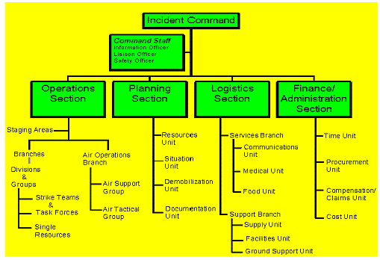
Many of the "served agencies" in our ARES work will be trained in, and use during emergencies, a common jargon and organizational structure called "ICS". This is an outgrowth of experiences in California wildfire management, where firefighters and other emergency personnel from various agencies regularly have to work together in different groupings than they've drilled. Use of ICS is now mandatory on all Fire departments and HazMat operations (including private sector!) has been adopted by FEMA and MEMA and increasing numbers of local Emergency Management Agencies (EMA's).

Standard Wildfire / Firefighting / Disaster ICS structure, from FEMA Standards

ICS has been used for planning in advance and execution of non-emergency events. For instance, according to the FEMA trainer, Fidelity (the major Boston investment house) planned and executed it's annual employee Christmas party (a pretty big event) using ICS (which was a major success, and validated their use of ICS for both business and environmental emergencies).

Incidents/Events that can Utilize the Incident Command System
- Fires, hazardous materials, and multi-casualty incidents.
- Single and multi-agency law enforcement incidents.
- Multi-jurisdiction and multi-agency disaster responses.
- Search and rescue missions.
- Oil spill response and recovery incidents.
- Air, rail, water, or ground transportation accidents.
- Planned events, e.g., celebrations, parades, concerts.
- Private sector emergency management programs.

It will be easier for us to provide communications support to served-agencies' operations if we are comfortable with their jargons and drills too. Indeed, demonstrated familiarity with their procedures and jargon may be necessary to get the foot in the door in some situations.
Training in ICS is available through FEMA/MEMA, on the WWW, private-sector commercial training, and (unofficially) via ARES.

ICS and Field Day Planning
Most clubs have a usual committee structure for their Field Day planning. The people planning and the people doing on Field Day are probably the same people -- and are exhausted by the time to clean up and prepare the logs for transmission. Most clubs' usual committee structures are probably -- due to the structures of common sense -- similar to the ICS-inspired structure proposed below. Some clubs may even already have assigned clean-up/demobilization/after-FD roles, which are so useful to avoid volunteer burn-out. The major advantages predicted for using ICS titles for your FD committees are:
- practice with the served-agency jargon
- emphasis on staffing by specific responsibility and in shifts
- remembering to plan and recruit for take-down and follow-up as well as the more glamorous set-up and operations.

An ICS Structure for Field Day Planning & Operations
The following is offered as a customizable template, not a carved-in-stone one-true-way. Clubs should do what feels natural, don't wreck your Field Day! But if they can migrate towards using ICS terminology and structures in their major events such as Field Day and Public Service Events, they'll be better positioned to provide communications to events and emergency agencies using the ICS. So feel free to edit the heck out this for your club, adjusting for how your club is comfortable dividing responsibility.
You don't need a large bureaucracy to do this ... One tenet of ICS is that several conceptual levels of hierarchy can be internalized into one person. The person responsible for a function splits out only the sub-roles that need delegating: but the ICS Names for the Roles let him/her quickly communicate to the various delegates who is doing what and make sure nothing is forgotten.
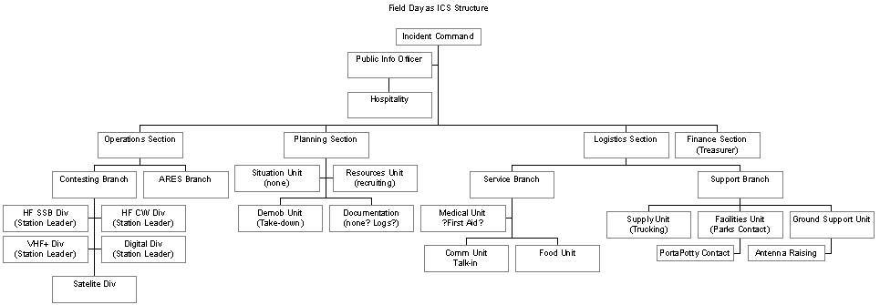
ICS for Field Day

ICS Structure

- Incident Commander = Field Day Chair

  - Public Relations Section = Public Information Officer (PIO)
    - Press releases before
    - Hospitality / Public relations at event
    - Press releases after
    - Might include VE Exam or other public-service/member-service function.
  - Planning Section [Field Day Chair & committee]
    - Situation Unit (what's the analogue for Field Day? someone doing SWL monitoring for opening or pileups, bird-dogging for the contesters? Site safety: watching the fires, liason with Skywarn or just listening to NWS to track incoming weather. Site security?)
    - Resources Unit (recruiting): Help other committees schedule people before FD. May utilize Talk-In (Logistics/Services/Comms) to recruit club members in real-time on Field Day.
    - Demobilization Unit (takedown): Planning who/how to take it all down, and (via Logistics) get it all, and everyone, back to where they belong.
    - Documentation: Preserve guest book, contest logs? May help plan logging process, process/submit logs afterwards?
  - Logistics Section
    - Service Branch
      - Communications Unit (this is where we, ARES/RACES hams, usually fall within someone else's ICS operation!): Talk-in and any other non-contest operations. Might include scoring the NTS points. Guard the usual repeaters, 146.52, and club simplex frequency for queries, relay information for any Supply unit and shuttle mobiles.
      - Medical Unit: First Aid plan / focal-point
      - Food Unit: (all important!)
    - Support Branch
      - Supply Unit: (truck-type transport; leg-work on purchasing for food and supplies; transporting borrowed equipment for other sections' unfilled requirements, e.g. antenna tuner, and return!)
      - Facilities Unit: (arrangements & interface with landlord/host; renting outhouses and other equipment; arranging borrowing of capital equipment based other sections' unfilled requirements, e.g., generator.)
      - General Ground Support
        - General hands -- everyone! (Antenna and tent raising, lugging)
        - Shuttle & Errands Group (car-type or passenger-van-type transport for people: shuttle to public transit stop, last-minute shopping, pizza-run)
        - Power Group runs the generator(s), charges batteries, manages available power. (does this fall under Facilities or General Ground? who cares, it's Support! Once you're operational, it's the primary component of Support, along with errands & shuttles transport.)
  - Finance Section (club treasurer or Field Day treasurer)
    - Club officials with spending authority; approve purchases based on club rules and FD budget.
  - Operations Section
    - This is where everyone thinks all the action is, but anyone who's been through Field Day realizes half the fun is in the above, everything else.
    - In ICS, Operations is divided into functional Branches as needed; with further geographic or functional Divisions or Groups, as needed. Most of our functional Divisions can naturally be called "Stations".
    - Contesting Branch (Contest Chief; shift supervisors)
      - Each Station counted in your 7-Alpha Field Day class would be one "Division" or "Group" for ICS purposes, both for planning and operations. Most clubs probably have a pre-existing idea of what equipment is required for each station and usually where to get it. Under ICS, a Station chief can ask for Logistics / Support / Supply assistance in getting loan (or purchase, if approved) for items that it's own staff can't loan or borrow from customary sources.
      - HF SSB Division Station (Station leader; shift operators, shift loggers)
      - HF CW Division (ditto)
      - VHF+ Division(s) (ditto)
      - Digital Division(s) (ditto)
      - Satellite Division (ditto)
    - ARES Branch = Emergency Coordinator or AEC
      - In using ICS, the club ARES unit can be made responsible for many of the Field-Deployment exercises of Field Day, in particular, Logistics (getting and keeping running the generator). However, the "contest" part of Field Day has many aspects that, while they belong in Operations, are still more ARES-like, in particular, the bonus points:
        - Ensuring power is according to operating class, i.e., emergency power.
[Operating as Power-management Group under Logistics above]
        - Making Natural Power contacts (for points)
        - Taking role call / check-in of ARES-enrolled members present (for SM/SEC radiogram)
        - Sending SM/SEC radiogram (for points)
        - Handling NTS traffic (for points)
        - Any other special points available (satellite or digital if no station?)

Contest Chief & Shift Supervisors
The Contest Chief may have Shift Supervisors to spell him/her on the Line. They should ensure operations conform to FCC and contest regulations, to protect the club's score & reputation and the license trustee. The Contest Chief or Shift Supervisor is responsible for seeing that there is a Control Operator of appropriate license grade supervising each station in use.
One particular concern for contest regulations to monitor is ensuring that the number of transmitters in use never exceeds the number permitted by the contest class, including ensuring that no two transmitters are under the same exemption at once. Some clubs have used physical Tokens for each counted and exempted transmitter, others expect active coordination with the Chief/Supervisor; others may fudge but that is not appropriate in a ICS operation!
Station Leader works with Planning/Resource-Recruiting to schedule operators & loggers; with Logistics to acquire (and return!) the equipment; and likely with the Contest Chief & Shift Supervisors during Operations.

Caution
Reading through the online documentation and training on ICS and using an ICS inspired committee structure is only the beginning. Please do not claim your Field Day was 100% ICS compliant just because you use the above outline as a committee template. This will set rather higher expectations in your local Emergency Management Agency than you would be ready to fill … unless all your Section and Branch chiefs have already been through FEMA-approved intermediate ICS training, in which case you're better prepared to write this memo than I! However, if the Field Day chair and one or more Section Chiefs (particularly Planning section chief if separate) had attended IS-100, the introductory ICS training workshop, or worked through the online equivalent materials, others have seen the A.R.E.A. ICS course, and others were signing up for the next ICS offerings, you'd be well on your way.

Acquiring Assistants

As was mentioned in the opening of this guide the secret of success is not relying on your own talents alone. This suggests that we bring the help and skills of our volunteers who have signed up for our committee as well as any of those who might be looking for something to do on the day of the event at the site.

Rule of Thumb: The more assistants you have the more easily and quickly things will get done. (That is of course if you have organized in advance of assigning them the details of what needs doing and when it is to happen.)

Titles to some are all the “pay” one needs to work to exhaustion in support of your committee. Now this doesn’t mean you should offer “appointments” in order to recruit, but if you sense that someone might jump in if you gave them the role of “Assistant Chairman” or “Work Team Leader”, etc., it could encourage them to participate. (Recognition never hurt anyone.)

Draw your assistants from the sign-up sheets you will put out at the club meetings (see Appendix “A” below) and from personal contacts with other hams and friends at the meetings.

Assignment List
Enough Said, the following should be at a minimum:

Position | Person Assigned
Station Leader 15m | Dan Bathurst WA7ABU
Station Leader GOTA | Rock Evans W7RCK
Station Leader QRP | Phil Westover
Station Leader 20m | Dean Davis KL7OR
Station Leader 40m/80m | Mike Brasher W7SST
Station Leader VHF/UHF | Drew Brasher
Setup | Dean Davis KL7OR
Photographer | Kruger
Talk In | Bobby Fling W7PCD
Food | Jan Davis
Pot Luck | Steve Hiltburn  541.926.0193 – H  541.928.2207 – W
Facilities -Power/generators
Bonus – Emergency Power | Dean Davis
Bonus – Media Publicity | Dean Davis
Bonus – Public Place | Dean Davis
Bonus – Public Information | Richard
Bonus – Message to Section Manager
Bonus – Message Handling
Bonus – Satellite QSO
Bonus – Natural Power
Bonus – W1AW Bulletin
Bonus – Demonstrations | Fred Sell
Bonus – Site Visitation

Acquiring Operators

As soon as you become a committee chairperson and get your packet of information from the Field Day Chairperson, find the sample sign-up sheet and set one or more out at the next club meeting for recruiting operators.

Encourage operators to sign up as soon as possible at the current or coming meetings.

Also encourage people to attend the field day pre-planning meetings. (The date and time will be announced by the field day chairman in the club newsletter and during the regular meeting during committee reports.)

Don’t overlook the participation of young people! There are many tasks that youths can accomplish in setting up, operating, and tearing down, even if they are not licensed hams and just “along for the ride” (An involved kid today is a happy ham at the next Field Day.). At one Field Day I was attending a small army of people were putting up antennas and I handed my camera to a teenager with instructions to take a whole bunch of pictures. When I got home I was pleased with the large number of usable photos. So, please include everybody.

Receiving Advice

Accepting advice is as valuable as requesting it, Many hams have done this Field Day stuff for many years and have been committee chairpersons themselves. If someone offers helpful advice and even offers to help carry it out, consider it with gratitude. If you believe the advice is applicable and needed, keep in mind the first suggestion of being flexible. Everyone wants to have a good time at Field Day, so thank advisors and let them know you appreciate their comments or offers of help. Never knowingly give them the impression that their ideas are not wanted or invalid. (When you “cast your bread on the waters,” it will always find its way back to you sooner or later.)

When in doubt, ask for help. Requesting helpful advice you will find, is often an essential part of finding out how to do things and where to find things. Never be shy about asking for any type of help. A self-confident, independent attitude is fine for contesting from your own shack at home, but it will only leave you a lonely overworked committee chairperson when Field Day arrives.

Food, Water, Shelter

Food
Our basic food/meal plan that has worked over the years is as follows:

Friday Lunch | Each person attending is responsible for his/her own
Friday Dinner | Coffee and lemon aid will be provided. Each person attending is responsible for his/her own
Saturday Breakfast | Club will be providing:  Oatmeal cereal  Selection of muffins  Coffee and tea  Lemon aid
Saturday Lunch | Each person attending is responsible for his/her own
Saturday Dinner | This is a pot-luck event and each person attending is requested to bring either a dessert or side dish.  The club will be providing:  Spaghetti dinner  Coffee. Tea, and lemon aid
Sunday Breakfast | Club will be providing:  Oatmeal cereal  Selection of muffins  Coffee and tea  Lemon aid
Sunday Lunch | Each person attending is responsible for his/her own

All during the Field Day coffee, tea, and lemon will be available at the food pavilion.

Shopping Lists

Staple Items

Plastic knives, forks, and spoons
Paper dinner plates
Paper dessert plates
Paper cereal bowls
Plastic cold cups, 20oz
Hot cups, 12oz
Paper Napkins
Plastic garbage bags, 40gal or better
Lemon Aid
Salt, pepper
All of the above items can be purchased at stores like Costco and stored ahead of time

Food Items

Spaghetti sauce 10 quarts
Ground hamburger meat, 10lbs. This should be cooked ahead of time and frozen.
Oatmeal cereal
Breakfast muffins, 3 12 muffin boxes
Croissants, 24
Coffee, 3 lbs
Tea, large box
Sugar, 2 lbs
Sweet and low, 150 pkgs
Creamer, 1 large bottle
Marshmallows, large box
Hershey bars, at least 48
Graham crackers, 3 boxes
Dry spaghetti pasta noodles, 18 lbs
Onions, 6-8 depending on size
These items should be purchased just prior to Field Day.

Last Minute

ICE,
Friday: 8 bags
Saturday: 8 bags
Fresh muffins from Costco
Milk

Field Day Setup

Number of Transmitters
The real fun in planning for Field Day is determining the number or transmitters or stations the club can support. Once you have your organization and people lined up you can design a setup that everyone can work with.
The main reason for the combined band stations are to make maximum use of the station for the full 24 hours. During the bottom of the sun spot cycle the following transmitter configuration should work well:
10/80
15/160
20
40

Hopefully on each mode. Obviously it is a little harder to do on CW and the digital modes where there are fewer ops to run things. Even with this mode, in the last sun spot dip there was precious little activity on 20 in the middle of the night and 10 meters and even 15 meters was all but gone. During the sun spot peak, you can go with monoband stations. This last year we had an arrangement like this.

Phone
10
15
20
40
80

CW
10
15/80
20
40

Digital
20/80
15/40 and 160 Phone (when the other two are dead)

Band/Transmitter Control
Requirement is to prevent two transmitters being on the same "band". (for purposes of contest, that means Band & Mode pair, where Mode is one of Data, Code, Phone - FM, AM, SSB are same "mode" for Field Day contest "Band" purposes.)
Tricky bits:
- If more than one HF transmitter with key or with mic, must ensure they don't wind up on same band at same time.
- on HF, a transmitter counts on that band for a minimum of 15 minutes, so must count extra transmitters if "moving contacts up the bands"
- on VHF+ (and including 10m), FM and SSB/AM are both Phone, so must ensure no Field Day contacts made on Simplex FM when VHF WS station is working 2m SSB.
- If a different station works the same mode later, having acquired the token, if they work a station we'd already worked from the first, it's a dup and doesn't count; embarrassing if they tell us, and negates points later for both of us if caught later. So want the first's dup-sheet or dup-file passed to second.

Band Token

Using a band token will insure that the above transmitter control is considered. During our field day events we have a simple tent card setup and when the event starts each of the stations has a tent card with the CallSign, Field Day mode (4A) and the band/mode. When a station moves the operator must get a new token.

Rules for control
HF rules: Station with one transmitter must have as many tokens as the number of bands worked in the last 15 minutes, which bands' tokens must be posted next to the transmitters' tokens. Other bands "reserved" for future QSY are posted separately. QSY to a band is only allowed if it is next to a transmitter token. If a Transmitter-token has no band next to it, a band token from the reserved set may be placed on the transmitter, allowing QSY. After 15 minutes off of a band, it may be retired to the "reserved" row. If more than one HF station is equipped for the mode in use, bands not likely to be used should be returned to central; new tokens may be acquired as may be useful.
VHF rules: Station needs as many tokens as transmitters being simultaneously operated (number of QSO operators), with all bands in use on that token posted next to it. Band-QSY on one transmitter is legal on one token, if both bands' tokens are held. QSY to another transmitter is also permitted by same operator, on one token, VHF+. (Note: 10m FM is still HF for this purpose?)
Physical: Tokens and central & station signboards are likely magnetic material - which can now be fed through inkjet printers. (Alternative is cardboard / plastic pockets with pocker-chip technology - more handycrafts required and less Presentable, but possibly more tactile satisfaction?)
Central board has 1 2 3 4 5 6 7 8 9 to be covered by Tx tokens; numbers higher than authorized covered by the "A" on a wide tag, and Tx tokens filed away for next year. Extra spots for each Free transmitter's token. Separate sign for bands available/in use. Maybe a separate sign counting which Bonus points have been scored, are in progress, and remain to be scored as a visible reminder system. [maybe bring a white-board?]
Signs in addition to being magnetic should have Velcro at corners, maybe grommets too, for versatile hanging.

GOTA (Get On The Air) Station

Introduction

This special station needs special attention since the rules for operation are different than other stations that are setup for Field Day.
Please see Appendix F for sample check lists, forms and other documents.

Frequently Asked Questions (FAQ)
Here are some Frequently Asked Questions about the Get On The Air station, adapted from the ARRL Field Day 2005 Publication.
Q. What is the GOTA station?
A. It is an opportunity for non-licensed persons, licenced Novice, Technician, Technician Plus licensees, other generally inactive licensees, and to experience first-hand the fun of amateur radio by allowing them to GET ON THE AIR.
Q. How many GOTA stations may a club have on the air?
A. Only one GOTA station may be on the air at any given time. Remember that a transmitter must remain on a band for a minimum of fifteen minutes once its initial transmission on a band.
Q. What are the bands for the GOTA station?
A. The GOTA station may operate on any amateur HF band on which Field Day is permitted. The SARC Field Day GOTA station may be operating on 40, 20, 15, 10 and 6 meters, coordinated with the other contest stations and antenna availability.
Q. What modes and frequencies may the GOTA station use?
A. The modes and frequencies are determined by the person in control of the GOTA station when it is in operation. If the person has a valid amateur radio license and is the control operator, they may operate on any band and mode permitted by their license. If the person does not have license privileges for the specific band and/or mode where the station is to be operated, there must be a control operator permitted to use the frequencies and modes desired in direct control of the GOTA station at that time. The SARC GOTA station will operate primarily in 'phone' (voice) mode.
Q. What callsign does the GOTA station use?
A. The GOTA station uses a callsign different from the call being used by the main group Field Day operation. Remember that you must have permission of the holder of the callsign in order to use it for the GOTA station. Also remember the rules of station ID. A two-by-three call issued to a Technician licensee may be used, but if the call is being used outside of the privileges of the licensee, it must also include the callsign of the control operator (KD7AAA/N7ZZ for example).
Q. Whom may the GOTA station contact?
A. The GOTA station may contact any other amateur radio station, with a couple of exceptions. The GOTA station may not work its own parent Field Day station. It may not contact any station operated by a person who was involved with their group’s Field Day operation. Remember that if a DX station (outside of the USA) is involved, the FCC rules involving Third Party participation apply. A complete list of countries with which the US has Third Party agreements may be found at

http://www.arrl.org/FandES/field/regulations/io/3rdparty.html.
Q. What is considered a generally inactive licensee?
A. The GOTA station is not for everyone. The generally inactive licensee provisions pertain to someone who holds a General or higher class license but was inactive. The intent and the spirit of this station is to provide an opportunity for persons to gain valuable on-the-air experience. This is not a station that a club “ringer” should operate in order to rack up points. The list of operators of this station must be submitted with the Field Day entry. A couple of guidelines to keep in mind when allowing persons to operate the GOTA station:
- Any licensee who has never made HF contacts would be considered inactive.
- Someone who has made no QSOs in the last two years would be considered inactive.
- A person who operated the GOTA station as a generally inactive licensee last year would not be eligible to operate the GOTA station the following Field Day. The club/group must provide a list of operators and the number of QSOs each operator makes at the GOTA station.

Clubs should use their judgement in determining the operators of the GOTA station.
Q. May someone operate both the GOTA and the main Field Day stations?
A. It is permissible for someone to operate both GOTA and the main stations. However, remember that to use the GOTA station, you must meet the requirements of license class, be generally inactive, or a non-licensed person. It is not permissible for a seasoned operator to operate the GOTA station.
Q. May a non-licensed person operate the GOTA station?
A. A non-licensed person may participate in the GOTA station by speaking into the microphone, sending CW, but may do so only under the direct supervision of a properly licensed control operator.
Q. I am an active Novice licensee. May I operate the GOTA station?
A. Yes. The GOTA station may be operated by any Novice or Technician licensee, under the terms of their license privileges, or under the supervision of a control operator.

ANTENNA

Finding / Creating

If you wait to plan for your antenna it could be overlooked entirely.

Check with club officers to see if an antenna already exists for use on your committee. Also check with the secretary who has a list of club assets to see if the club has an antenna you are looking for. In a group that has done this for years you will usually find one dedicated to your committee especially for Field Day or someone will have one that can be borrowed. Our club already has beam antennas on the club trailer waiting to be cleaned up and assembled.

If all else fails, grab your ARRL literature and start studying the mechanics of building and testing an antenna. If you undertake this early in the process you will have a tried and true “wave catcher” well before Field Day.

Rule of Thumb: “The effectiveness of an antenna and its cost have no relationship.” A piece of scrap copper wire cut to the correct length and tuned properly may even out perform a commercial antenna.

Remember that in the club we have an excellent Field Day operating site, so even a moderate antenna will do a fine job for you. So as they say in the military KISS (keep it simple, stupid), no offense intended.

Antenna Supplies
Be sure to bring along a lot of extra antenna supplies as you never know when you will have to build one in hurry. The following is a partial list of items:

Installing

In the formal Field Day rules we know that extra points are available when one waits to set up the station until the beginning of the contest. But the club usually forgoes this because of the size and complexity of our multi-committee site setup. However getting help setting up is easier when the installation is thought out and started as early as possible. This means that Friday Noon is not too soon to start installing the station. It will also mean that you will be ready to call on the available hands that are there as soon as they are finished with another installation, or may even be first in line for labor.

To handle removing corroded screws and nuts (a can of your own hardware might come in handy), wire brush for cleaning joint surfaces, rolls of electrical arid duct tape, and any extra transmission line and short pieces with connectors (its difficult to assemble connectors in the field) for linking the radio, tuner, meter, etc. Also any battery operated power tools make the job so much simpler, but these are strictly optional.

Teamwork is essential to a good antenna raising or lowering. If heaven forbid you should have to climb a tower, be sure that you obtain the use of appropriate gear such as an approved safety belt, hard hat, gloves, tool belt, hard soled footwear, and support personnel with some experience before you do.

Wire antennas can require as many hands as handling a rigid beam, but don’t require helpers to know any more than how to hold and pull a line when instructed. So you will have no trouble recruiting people to help draw up a wire in the air (don’t forget the young people standing around watching). The club also has some large stakes manufactured out of steel for rope attachment to the ground, please use them.

Teardown at the end of Field Day is usually the poorest attended part of the weekend, but it as rewarding as seeing the original setup take place. Encourage people to come back who helped put it all up, especially the young ones who are just learning how this marvelous antenna farm is assembled. It is a tremendous learning experience to take apart something they have put together. They usually can sway the exit timing of the older folks who are in a rush to depart for home or further relaxation.

Locating your antenna is usually well known by those frequent attendees at Field Day. If you are designing your antenna then check with the Field Day Chairperson(s) for advice on the physical layout for your committee.

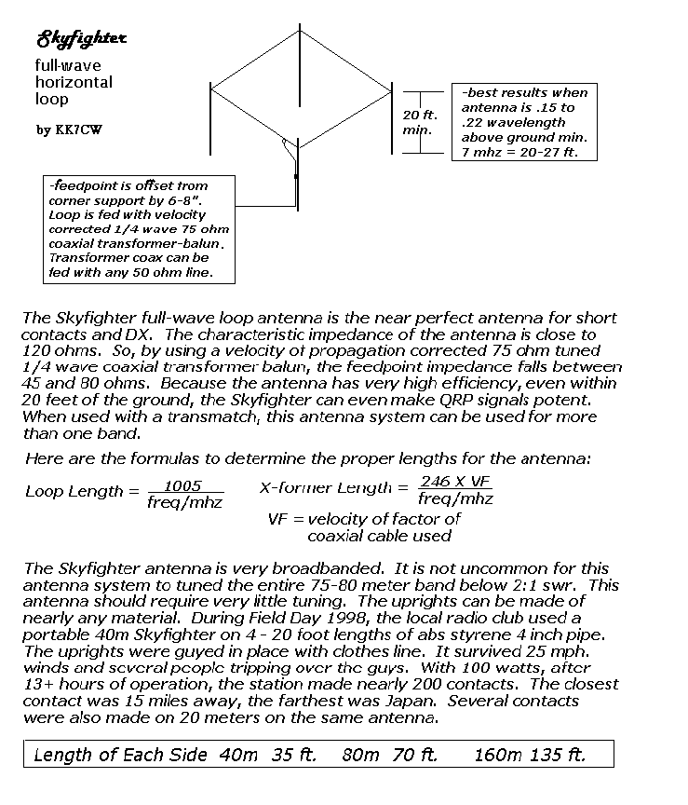

STATION HARDWARE I SUPPLIES

Furnishings

Basic furnishings will be the same for all station sites as follows:

- Operating tables should be sturdy enough to support the radio gear, but portable enough to get on and off site with relative ease, A folding card table or picnic table is good.

- Chairs should also be easy to transport and handle, but remember that if your committee is usable for long hours, then people function better with a good chair to sit in. Folding chairs take up the least space, but light weight resin patio chairs give added comfort to the back and arms.

- Floor preparation is necessary for tents. The floor should be protected from accidental puncturing from chairs, etc.

- Display of clipboard or bulletin boards provide a place to hang schedules and post information about your operation. This is especially nice if you have visitors who are not hams (PR is part of the game) and a sign can be worth a thousand words.

- Operating supplies such as writing instruments, clipboards, scratch paper, extra log sheets (which must be used even if your computer logging, to confirm entries during and after the event or in case of a computer crash), facial tissues, stick pins, paper clips, etc

Lighting
Lighting is necessary for good logging. A small desk lamp (incandescent preferred) can provide enough light without adding to the generator load significantly,

Place the light higher than the operators, but not so high that the candle power (visibility) is reduced. On top of a box or rig may be enough.

Extension cords are a very good idea, long as well as short ones. And a multi-plug receptacle box (homemade or commercial) can make easier electrical setup.

Pieces / Parts / Tools

A raid on the home shack junk box is a good start to planning for Field Day. Picture in your mind’s eye what you would do if a connector came unsoldered, or a fuse New, or a tube failed in the older Field Day radio. You can’t possibly anticipate all calamities, but bringing along enough tools and parts for what you can imagine in 10 minutes of “what if’ daydreaming can save you a lot of scouting during the contest to find fixes to get back on the air.

Hand tools includes both mechanical devices such as wrenches and sockets and electrical devices such as wire stripers, match solder, needle nose pliers and volt/ohm meters. Other things break along with radios.
Remember, check your own Field Day check list and insure that YOU bring everything that you will need for the event.

RADIO ACCESSORIES

Radio (Rig)

Sources for radios range from club owned equipment, your own home station equipment, or borrowed extra rigs often dedicated to field use, The important thing is that the equipment works before it arrives at the site of operation. Usually someone who volunteers to help on a particular committee will have a rig that can be used or asking around at the club meetings can net you an extra rig someone has to loan,

The type of rig is not as important as making sure you have at least one available. If it is possible to arrange for an extra to be available during the operation will insure that no time is lost if something goes wrong during Field Day. Even if this can’t be arranged there are a lot of experienced people present at this event to help work out the problems, such as the case during Field Day 2000 when the Novice/Tech station failed.

During a contest of any kind you may find it helpful to put out as much usable power to the antenna as possible, so even if the radio is not state-of-the-art if it can pump out some big waves it is much appreciated. We all wish we could have the latest stuff; even at Field Day.

Phones, Mikes & Switches

A most vital equipment consideration for a contest is the listening and speaking devices connected to the radio, A pair of similar headphones (same impedance) connected with some sort of tandem (split) cable to the rig is essential.

The microphone while also essential can prove to be a slight hindrance if it is not arranged so that the operator’s hands are free to write or type on the computer keyboard. This is accomplished by means of a foot switch. While you are listening to a return message from the airwaves, you may need to say something to the person logging next to you or write a note to clarify what you think you just heard over the headset. This rules out the use of any kind of voice operated (vox) microphone. All or part of this equipment can be homebrewed or purchased to compliment a specific setup. If you need to make such a setup you could check with experienced operators in the club who have either prepared nice matched sets in advance of a field operation or who have had to make something up on the fly at the site of the operation. Ask around.

Also needed are paddles, keyers, and bugs for the CW operator. Each person should bring his own since he is most comfortable with his own settings. If you will be using an electronic keyer please take the time BEFORE the event to enter new data. The Field Day logging program we use also has support for electronic keying.

Meter, Cables, Components

The basic metering you need to set up a working station is the SWR (standing wave ratio) and or power meter. This is your primary tool for determining how well you rig is electrically “seeing” you antenna system. Even if the standing wave indication was a little high you might be OK if you could see that your power output was adequate. SWR indications can be misleading if the meter happens to be on either side of the null point for the frequency wave traveling on the transmission line. But if you don’t have a meter you can’t be remotely sure that an optimal arrangement has been reached between the rig and the antenna. Also keep in mind that if you must use a tuning device to electrically match to the antenna it should go in line after the meter. To put it close to the rig before the meter would give you no idea of what the rig “sees” from the work of the tuning device. You could appear to have matched the antenna and the rig’s automatic tolerance circuit cuts your power down or off because it is actually experiencing a high power reflection. In an older rig you might even be overloading your tubes. So some care should be taken in planning your hook up to the antenna system.

This is where it is a good idea to have some extra lengths (varying from a foot to three plus feet) of transmission line with fittings attached to allow flexibility at the setup site for various sizes and styles of rigs, meters, and tuners to be attached together. Trying to cut and solder these jumpers in the field is no fun.

As for what I call components, some people have other devices they like to use to better appreciate what their signals may be doing as they are created and dancing their way to the antenna, Items such as active audio filter boxes, video display scopes, automatic code boxes, antenna rotator controls, etc. These all need to be considered in the layout of the shack (tent, trailer, etc.) for best use of space and convenience of operators. If you are not sure what will be going into the shack, leave yourself a little extra room for variations in your plan. The next critical area to that of rig related failure, is power failure. We are fortunate to have the use of a primary generator to provide power to the site if necessary (battery charging, coffee pots, etc), but this is no guarantee that Murphy will not put is foot in the gas line right in the middle of the day. So if it can be arranged, it is advisable to have auxiliary power standing in the wings in the form of small generators capable of keeping your station up if the main generator fails. This may not be possible for many, but it should always be looked at with the help of your committee members as an important consideration in the planning stages.

LOGGING HARDWARE I SOFTWARE

Recording Instruments

In order to qualify for any deserved consideration by our fellow hams, it is necessary according to the rules of ARRL headquarters that we submit to them a record of our contacts with other stations that includes no duplications. The methods for doing this have gradually refined over the years of Field Day operating and are looked at each time a newer technology comes along.

Log sheets were and still are the most dependable documentation of on-air activities. With each set of committee materials a supply of log sheets will be provided. While these are not the primary records they may be needed if Murphy steps in again to gum up our rapid recording tools.

In recent times we have rapidly progressed from dragging power supplies and bulky desktop computers out to the shack to flipping open the top of a slim lightweight laptop computer to record and check duplicate contacts on the fly. But not everyone will be privy to such refinements, so don’t be embarrassed if all you can manage to bring or borrow is a big early model desktop. Remember that even the new laptop is only as fast as the software we are all sharing to put this show on. Whether a floppy is 5.25 inches or 3.5 inches as long as it contains the info we need it is highly respected by the Field Day Chairperson(s).

Speaking of software, the program, FLDDAY17 Field Day Logger, that the club has purchased is usable with very little coaching. If you have a computer at home and would like to become familiar with it, see the chariperson to get a copy to practice on. It might encourage someone if you offer a blank disk when you request a copy.

In regards to disks it is essential if you can find a machine that takes high density 3.5 inch floppies (not actually floppy because they are housed in a stiff little plastic case).

SITE PREP & MAINTENANCE

Shelter

Depending on which committee you are organizing, you could be looking at setting up in a trailer, state shelter, or in a atmosphere changing camping tent. If you are one of those who is a specialist at his trade like our resident moon bouncer, satellite tracker, sun power worshiper, you could be sitting in a comfortable motorhome. It is not important what physical shelter you occupy, but it is necessary to know how best to prepare for that type of shelter.

Cleaning is a necessary part of all shelters; even at home. Be prepared to have a broom and dustpan of some sort. Also the tent floors will last longer if we are not laying heavy objects on top of last year’s sticks and leaves.

While tents require actual assembly and putting down a rug or plywood to prevent table legs from damaging the floor. Also in the tent you may want to consider items such as tape and pins for any emergency repairs.

The often forgotten part of setting up is tearing down. For some reason there always seems to be a few less hands during this phase, but we seem to manage. It would be so much more rapid and fun if more people stayed to help. Committee chairs should take every opportunity during the weekend to try to determine by invitation how many might be able to remain to assist clearing it all away.

Safety is a big item where so many people are involved in using electrical and power equipment. Power leads and coverings should be secure and in place when the generators are operating. Cords and cables should be placed so that they can’t be easily damaged nor can they pose a dangerous obstacle to passerbys from falls. It behooves a committee chairperson to see that safety is practiced by everyone who enters your operating domain. This is well understood by our faithful climbing crew that scales our towers to set our beams against the heavens. All safety efforts will ultimately enhance the comfort of our people as well. Should anyone however have need of assistance from accident or illness, an appointed first aid provider will be available to handle splinter fingers and vital assistance. But prevention is the best insurance.

Water
After the site has been secured check to see if there is running water and if it can be used as drinking water. For Field Day 2001 we were at a location that did not have water. If you need to bring in bottled water calculate that each person could drink up to 1 gallon per day during hot days. And what ever you do plan for hot, 90+ degree days. If the weather is cool and you do not use all of your water you can always donate it to one of the public service activities of the club.

N3FJP Computer Logging

Overview
This Field Day Logging Program was written for the enjoyment of all amateur radio operators. It requires Windows 95/NT or later versions.

Primary Features

This program checks for duplicates (including partials), lists the sections (which change color when they have been worked), lists all contacts, writes ASCII log dupe and summary files, and provides many current statistics.

One of the nicest features is that the program allows you to tab automatically without pressing tab or space bar (although you can if you want to). Just type the exchange, and the program will jump from one field to the next automatically.

I hope you find the program intuitive. Here is a brief summary of the setup, some of the controls and displays:

Menu Bar Commands

File - New: This will erase all data to begin a new contest. Once the data is gone, it is gone. Make sure you have copied and renamed any log files you may wish to keep.

File - Write: Use this option to write the ASCII Summary, Dupe and Log files to your program's working directory. If you would like a hard copy, these files can be printed with a text editor such as Windows Notepad. Cabrillo files are NOT used for Field Day contest submission.

File - Export for ACLog Import: This will export your contacts in an import ready format for the Amateur Contact Log program. The file to import is LogExp.txt and will reside in the working directory of this logging program. (If you don't have a copy of my general logging program and would like to give it a try, please download it from my website.)

File - Export ADIF: Exports your log in ADIF format.

File - Combine or restor from backup. Every 15 minutes the program will write a backup file of your entire log file in C:\Program Files\FldDay\LogBkUp.DAT. You can use this function to restore data from your backup file or combine logs from other PC's. To combine the files from 2 PC's, do the following:

1. Make backup copies of both fdlog.dat files (not required but highly recommended)
2. From the 2nd computer, put fdlog.dat on a floppy
3. Put the floppy in the 1st computer
4. From the Field Day program's file menu, click Combine or Restore from backup
5. Click browse, navigate to your floppy drive and select fdlog.dat
6. Click append
7. Click done.

Options - Transmit - Use to set up your automated CW and voice functions.

Options - Appearance - Select form size and colors.

Options - Appearance - Task Bar - Enable the program to detect the taskbar location and adjust the form size automatically.

Options - Rig Interface - Use to read frequency and mode from your transceiver.

Options - DX Spotting - Use to configure your spotting options via Telnet, TNC or AGW Packet Engine.

Options - Voice Navigation - I have received several requests to provide support for visually impaired hams, and I would like to do whatever I can. I am beginning by providing voice location on the main form. After you copy the necessary wave files, as each data entry field receives the focus, an audio wave file of my lovely XYL, Kim, KA3SEQ, will identify the field. I have specific setup directions on the Voice Navigation form.

Options - List Previous Contacts - If checked, when tabbing from the Call field to the next field, any previous contacts with the current station on other bands or modes are listed.

Setup - Use to change the display of your exchange, utc setting and contest type.

Band - Select current band. Also, a statistics section is available which displays the number of contacts you have made on each band.

Mode - Select current mode.

Beneath the menu bar you will find:

Recent Contacts - Displays recent contacts. To edit or delete a contact, click on the Rec#. Edit and delete command buttons will appear. Click the appropriate button.

Data Entry Boxes - where you enter the contact information.

Communications Box - under the Data Entry Boxes is a Communications Box which will alert you to dupes, etc.

Possible Duplicates - This feature is handy because you can use this to see if the station is a dupe or not before you have entered the whole call. It displays any call you have already logged that matches the portion of the call you have entered.

Band - Displays the current band you are on.

Mode - Displays your current mode.

Score Statistics - Include total contacts by mode, total QSO points, average qso's per hour last 20 minutes and average qso's per hour last 60 minutes.

Sections Worked - All sections are continuously displayed. The section color will change from red to blue when you work the section for the first time. Move the mouse over the section abbreviation, and the name of the section is displayed. Also, in the Possible Duplicates Box the total number of times you worked the section and the number of times you worked the section on each band and mode is displayed. There is no multiplier for working additional sections; however, it is a neat feature that will let you quickly show visitors all the places you have worked.

Screens
When you first start up the program you will receive the following screen:

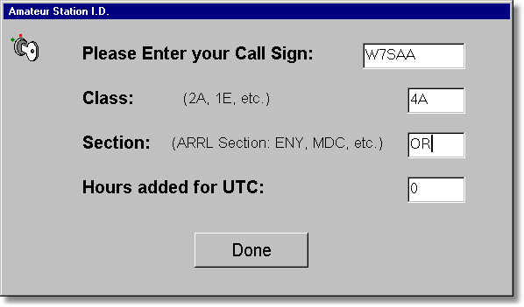

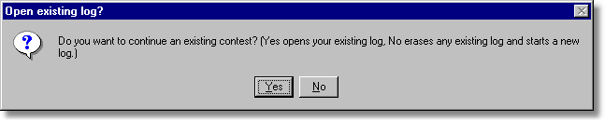

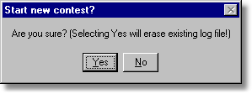

Main Logging Screen

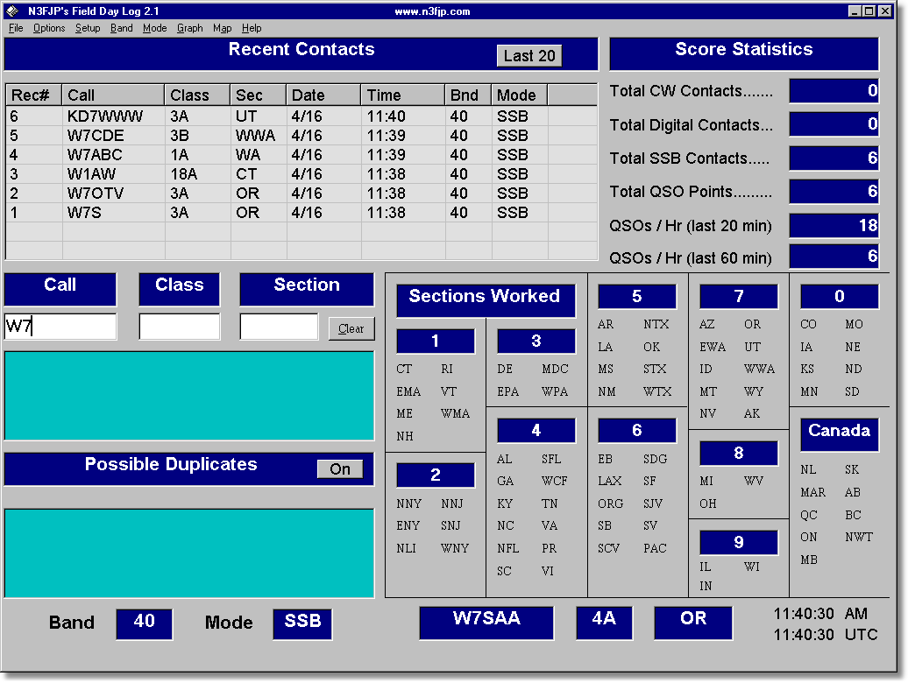

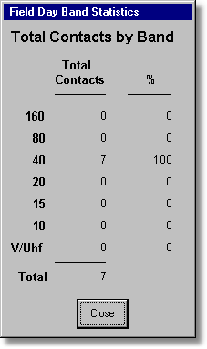

STATISTICS REPORTING

Scheduling of Operators

I know that it may seem odd to mention obtaining committee operators at the end of this manual. But when it comes to Field Day, one of the best things is being able to pick and choose when and what one will do during those fun packed twenty-four hours. Therefore, while some will sign up in advance at the club meetings to be part of a given committee, many others will make that choice when they are at the site. This is why a committee chair needs to post his availability schedule both at the dining area and at his operating shack. This way those who pass by day or night can sign in an empty slot and sit down at the table. While specific time periods have been allotted on the form to help give everyone a chance to operate, flexibility is the name of the game. Some may have their favorite times and others may fill in empty spots. However since the highest motive of the day is to have a good time, that should make the committee chairman’s job one of encouraging operators and not discouraging their desires.

Both the sheet logs and computer logs should be prepared as the event develops. The computer program will allow that if a disk is left in an active drive slot, each time an entry is confirmed it will automatically update the floppy disk. This offers some protection against lost data in a system crash. It is much easier to fill in the gap from the written log sheets than to have to rebuild the whole day lost from the computer.

When the fin is finally ended, it is the responsibility of the committee chairperson to see that the disks are collected along with the log sheets and presented as soon as possible’ (preferably before leaving the park) to the Field Day Chairperson. That is when the not so fun part of preparing the results starts with the person(s) who managed the weekend.

Reporting to the ARRL
Sit back and take some time for your self. Field Day is over and all that is left to do is to combine the logs into a single log file using the N3FJP program. At the conclusion of Field Day you should have gone to each of the stations and copied the log file to a diskette. Right? Using Notepad combine all of these into a single file and create the summary sheet and dup sheets.
Here is what you should be sending to the ARRL:
- Field Day Summary sheet from the logging program
- Dup Sheets (log) from the logging program. This should be by band and mode
- GOTA Station log
- Proof of bonus points. Photos work well here. Also include all press releases articles from newspapers, visitor logs, NTS messages handled, plus anything else. I also include a CD of all photos taken along with a printed copy of this book and all sample forms.

Send your material to:
Field Day Entry
ARRL
225 Main Street
Newington, CT 06111

Remember it MUST be sent to the ARRL within 30 days of Field Day to be counted.

Afterglow

This item is not mentioned in the description of this section of the manual because it is the real secret of being a committee chairperson. When you turn in those stats to the Field Day Chairperson(s), you have a pretty good idea of how much was accomplished and what part you played in the remarks you have been hearing at the campfire and operating shack about how it will compare to last year. This is when your feeling of pride in a job well done settles over your weekend. Try it out and see if you don’t agree this is the greatest job in the club.

Appendix A – Antenna Ideas

Appendix B – Press Releases

Appendix C – Field Day Invitation

Appendix D – Information Sheet

Appendix E – Forms

Appendix F - GOTA Documents/Forms

Appendix G – Other Documents

